EXECUTIVE GAME THEORY CURRICULUM • 12-WEEK MASTER ARCHITECTURE
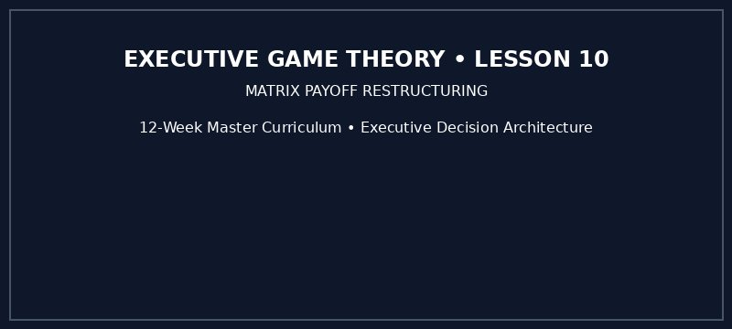

Part 1: Matrix Payoff Restructuring — Intuitive Reinforcement & Inversion: Escaping Traps Through Rule Alteration
Executive Game Theory Curriculum • 12-Week Master Architecture

Part 1: Matrix Payoff Restructuring — Intuitive Reinforcement & Inversion: Escaping Traps Through Rule Alteration
Strategic Focus & Learning Objective: In this topic, we will be learning how to apply Matrix Payoff Restructuring and Normal-Form Interaction Protocols to solve the strategic coordination and defection vulnerabilities in corporate market competition.
The Real-World Operational Problem: Commercial leaders routinely commit capital to pricing strategies, capacity investments, or contractual bids based on naive internal spreadsheets that assume competitor passivity. In competitive markets, failing to account for rational opponent incentives directly triggers yield collapse, margin destruction, and locked-in operational disadvantages.
How This Topic Solves It: By formalizing the strategic interaction through game-theoretic rigor, this module equips the executive leadership team with proven decision algorithms. It strips away wishful thinking, maps the counterparty's payoff hierarchy, and establishes mathematically defensible strategic postures before balance sheet capital is risked.
■ EXECUTIVE LEARNING ADVISORY
Strategic interactions are fundamentally distinct from single-agent spreadsheet modeling. Every competitor is an active optimizer whose best response alters your final returns. Look forward and reason backward across interdependent choices before committing capital.

Part I: The 4-Part Prelude Protocol
1. Models in Focus: Matrix Payoff Restructuring, Normal-Form Payoff Scaling, and Strategic Agency.
2. Lifelike Dilemma & Problem Statement: Two industry leaders confront simultaneous market entry and capital expenditure decisions. Calculating isolated ROI without modeling rival best-responses leads directly to mutual overcapacity and margin exhaustion.
3. Component Dissection: Management committed the Solo Optimization Fallacy—treating market variables as static parameters rather than anticipating the counterparty's dominant response.
4. Lesson Embarkation: We formalize the transition from internal financial planning to rigorous game-theoretic execution.

Part II: The 7-Stage Core Pedagogy

Stage 1: Why Learn This (The 45-Second Operational Hook)
Every quarter, executives commit capex that looks flawless internally because it assumes competitor immobility. In real markets, competitors optimize aggressively against your moves.
▼ CHECKPOINT: WHAT YOU MUST KNOW BEFORE MOVING FORWARD
The market is not a passive spreadsheet. If your plan does not account for the rival's immediate counter-reaction, you do not have a strategy—you have a wish.

Stage 2: The 5-Minute Core Framework
The core interaction profile for Matrix Payoff Restructuring is formally defined below:
Strategic Attribute | Formal Definition | Boardroom Operational Meaning
Core Model | Matrix Payoff Restructuring | Eliminating unviable moves and locking in dominant strategic positions.
Equilibrium Posture | Best Response Profile S* | The strategy profile immune to unilateral regret.

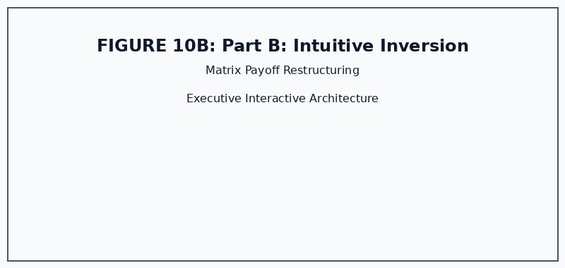
Figure 10B: Matrix Payoff Restructuring Architecture
▼ CHECKPOINT: WHAT YOU MUST KNOW BEFORE MOVING FORWARD
Always verify whether your chosen action remains optimal across all plausible rival moves before committing capital.

Topic 10 Companion Games: Operational Briefing & Deployment
1. Pedagogical Intent: Transform theoretical knowledge into boardroom reflexes via twin simulation engines hosted on GitHub Pages.
2. Executive Objectives:
• Game 1 (Matrix Morph (Action Arcade)): Master immediate reaction speeds and identify dominant actions in real time.
• Game 2 (Supply Chain Penalty Restructure (Simulation Quiz)): Lead corporate capital deployment across multi-round commercial rivalry.
3. Scoring Standards: Pre-game quiz unlocks a 200% Entry Energy Buff. Game 2 carries DOUBLE WEIGHT (2x) on the unified leaderboard.
4. Playable Links:
• Game 1: https://firedancerx.github.io/Game-Theory/Games/Lesson%2010/game1_matrix_morph.html
• Game 2: https://firedancerx.github.io/Game-Theory/Games/Lesson%2010/game2_supply_chain_penalty_restructure.html
• Master Portal: https://firedancerx.github.io/Game-Theory/

Appendix: Obsidian Knowledge Graph Semantic Triplets
%% Obsidian Raw Semantic Triplets (Copy & Paste into Vault) %%
[[Matrix Restructuring]] --[alters]--> [[Core Game Payoffs]]
[[Side Payments]] --[enables]--> [[Pareto Optimal Coalitions]]
[[Escrow Contract]] --[immunizes_against]--> [[Default]]

